Activity: Using JavaScript Language Objects

Problem Statement



RoundTheClock, Inc. is an event management company based in North America. The company currently has a static Web site displaying generic information about the company. The company plans to organize a Rhythm and Blues concert on the event of New Year s Eve. The senior management of the company wants to modify its Web site so that each time the Web site is loaded, the home page displays the current day, date,

month, and year in the upper-left corner. Also, the home page should provide information

about the number of days left for New Year s Eve. The visitors should be able book tickets for the concert through the Web site. David Simmons, a Web designer at RoundTheClock, Inc., has been assigned this task. Help David achieve the desired outcome.

Solution

To solve the preceding problem, you need to perform the following tasks:

1. Create the user interface.

2. Write the script.

3. Verify the solution.

Task1: Create the User Interface

To create the user interface:

1. Start the Notepad text editor.

2. Type the following HTML code.

<HTML>

<HEAD>

<BODY>

<FORM NAME="myForm" method=POST ACTION="message.html">

<P>

<BR> <BR>

<CENTER> <H3> TICKET BOOKING FORM </H3> <CENTER> Ticket Category:

<SELECT name="dropdown" onchange="put()">

<OPTION>$50

<OPTION>$100

</SELECT>

</P><P> Your Name:

<INPUT type="text" name="name">

<BR>Your Address:

<INPUT type="text" name="address">

<BR>

<INPUT type="Submit" value="Submit">

</P>

</FORM>

</BODY>

</HEAD>

</HTML>

Task 2: Write the Script

To display the current date and days left for the New Year s Eve, add the highlighted code to the code you have written:

<HTML>

<HEAD>

<SCRIPT LANGUAGE="JavaScript">

var d=new Date()

var weekday=new Array("Sunday","Monday","Tuesday","Wednesday","Thursday","Friday","Sa turday")

var monthname=new

Array("Jan","Feb","Mar","Apr","May","Jun","Jul","Aug","Sep","Oct","No v","Dec")

document.write("Today's date:") document.write(weekday[d.getDay()] + " ") document.write(d.getDate()+ " ") document.write(monthname[d.getMonth()] + " ") document.write(d.getFullYear())

</SCRIPT>

<BODY>

<SCRIPT LANGUAGE="JavaScript">

today=new Date()

nextXmas= new Date("December 25, 2004") nextXmas.setYear(today.getYear()) msPerDay=24\*60\*60\*1000

daysLeft=(nextXmas.getTime()-today.getTime())/msPerDay

daysLeft=Math.round(daysLeft)

document.write("<BR>" + "Number of days left for the event is:" +

daysLeft)

if (daysLeft >=15)

document.write("<BR>" + "Keep patience! It's a long way to go")

</SCRIPT>

</BODY>

<BODY>

<SCRIPT Language="JavaScript">

function put()

{ combooption=document.forms[0].dropdown.options[document.forms[0].drop down.selectedIndex].text

txt=combooption document.forms[0].favorite.value=txt

}

</SCRIPT>

</BODY>

<BODY>

<FORM NAME="myForm" method=POST ACTION="message.html">

<P>

<BR> <BR>

<CENTER> <H3> TICKET BOOKING FORM </H3> <CENTER>

Ticket Category:

<SELECT name="dropdown" onchange="put()">

<OPTION>$50

<OPTION>$100

</SELECT>

</P><P> Your Name:

<INPUT type="text" name="name">

<BR>Your Address:

<INPUT type="text" name="address">

<BR>

<INPUT type="Submit" value="Submit">

</P>

</FORM>

</BODY>

</HEAD>

</HTML>

The preceding code creates an Array object, monthname, which stores the months in a year. In addition, the days of the week are contained in the Weekday array object. The variable daysLeft displays the number of days left for New Year s Eve. The form myForm allows the visitor to book the show ticket in advance.

Save the document as tickets.html.

Task 3: Verify the Solution

To verify the solution:

1. Verify the output by loading tickets.html in the Web browser. When the file loads in the Web browser, it displays the current date and the number of days left for New Year s Eve. In addition, the file also displays the ticket booking form that allows the user to book the ticket online. The following figure displays the output of the preceding code.

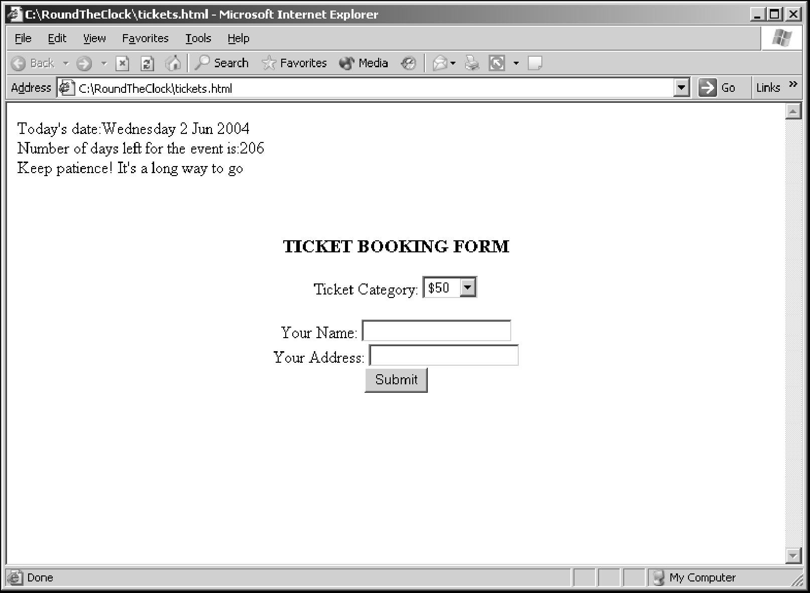

Code Output

2. Enter the necessary details and click the Submit button. A confirmation message is displayed, as shown in the following figure.

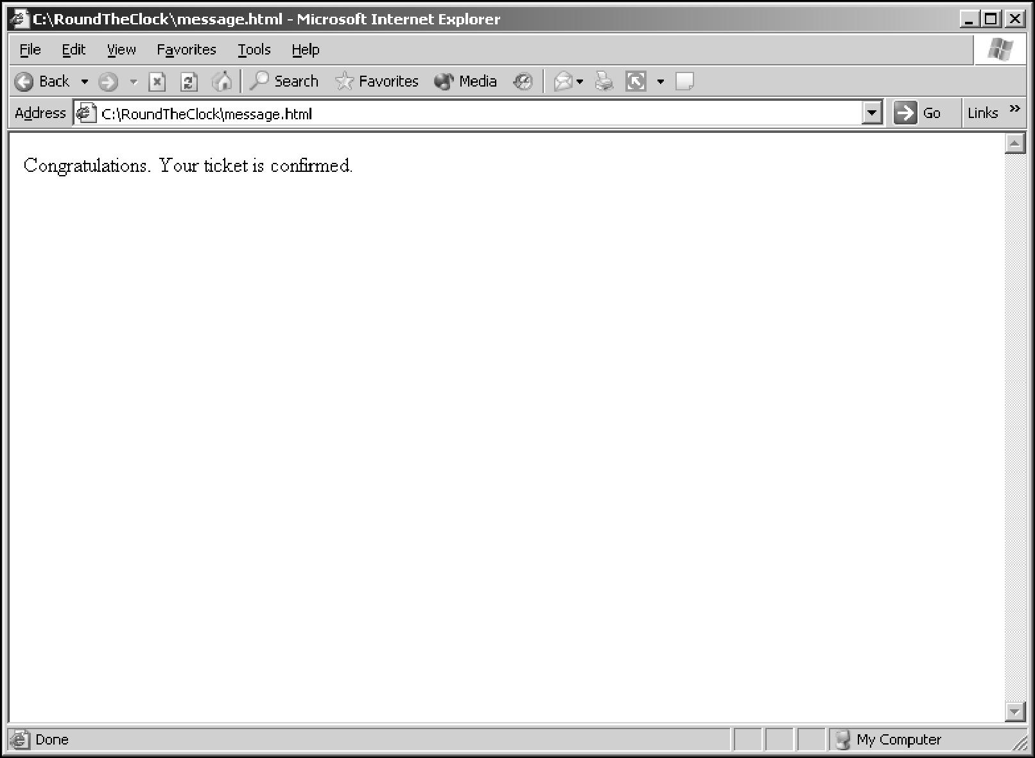

Code Output